Object Oriented Analysis and desing with Java Assingment

PART A

Botswana Accountancy College

Cse24-106

Part A: System Documentation

# Requirements Elicitation

* 1. Functional Requirements:
     1. Customer Registration:
        + The system must allow customers to register by providing their details depending on if they are an individual customer or an organization or company. The details required for a customer are: first name, surname, national ID, address, phone number and email address. The details needed for a company or organization are: company name, registration number, company address, contact person and contact phone.
        + These are essential so the system must validate required details before the account is created.
     2. User Authentication:
        + The system must allow registered users to be able to log in with their username and password.
     3. Account management:
        + The system must allow users to open one or multiple account being: Savings, Investment and Cheque accounts.
        + The system must also be able to apply specific account rules being:
        + Cheque account: Needs a proof of employment and should allow deposits and withdrawals.
        + Savings account: Withdrawals are not allowed but deposits are and a monthly interest rate of 2.5% for individuals and 7.5% for customers.
     4. Transaction history:
        + The system must record all transactions made being: deposits, withdrawals and interest payments.
        + Customers must be able to view their own individual transaction histories.
     5. Depositing of Funds:
        + The system must allow a user to deposit any amount of funds into any of their accounts.
        + The system must update the account balance immediately after the action is processed.
     6. Withdrawal of Funds:
        + The system must allow a customer to withdraw funds from an appropriate account being: investment and check only.
        + The system must check the balance of the account before carrying out the withdrawal request.
     7. Multiple accounts management:
        + The system must allow a single customer to manage multiple accounts simultaneously opened in their name.
        + The system should allow the customer to perform different operations on the multiple accounts a customer may have opened.
  2. Non-Functional Requirements:
     1. Security:
        + The system must prevent unauthorized access through user authentication.
        + The system must not allow any unauthorized user to access the system.
     2. Performance:
        + The system must process deposits and withdrawals within 3seconds.
        + The system must deliver a fast experience to the user.
     3. Usability:
        + The system must provide a user-friendly interface with clear-navigation for various account operations.
        + Error messages must inform and guide users to correct their mistakes.
     4. Data Integrity:
        + The system must ensure that the account balances are accurate after every transaction
        + Interest calculations must be in accordance with the bank rules.
     5. Reliability and Availability:
        + The system must be up 99% of the time to always be ready for customer requests.

# Structural UML Modelling

* 1. System Use Case Diagram:

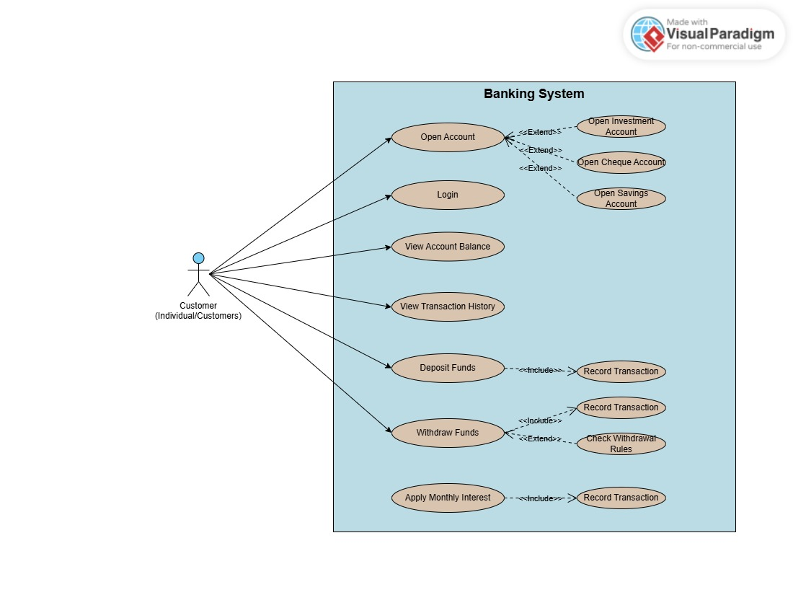

* 1. Class diagram:

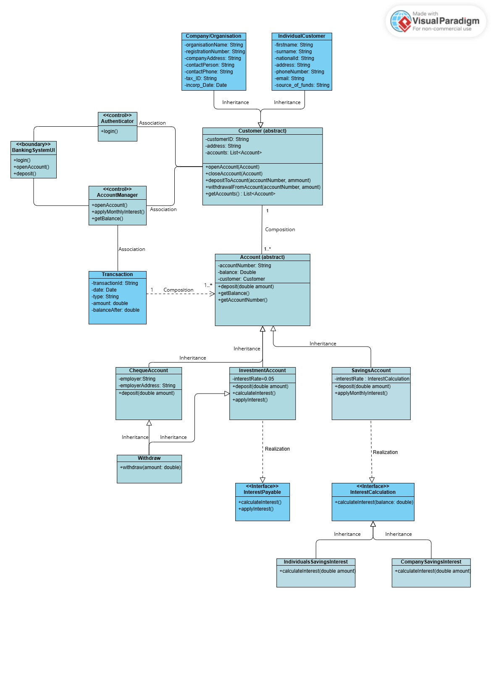

# Behavioural UML Modelling

* 1. Sequence Diagrams

Login Sequence:

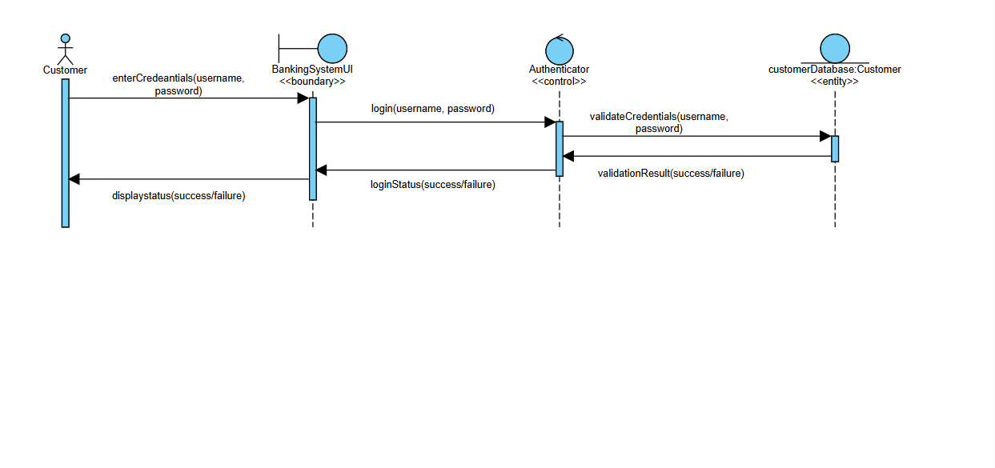

Opening an Account:

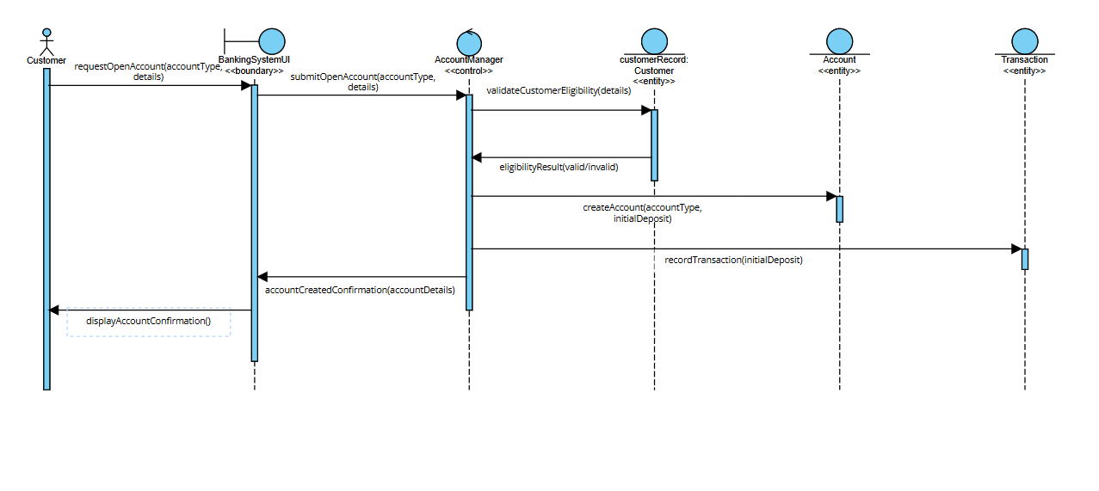

* 1. State Diagram:

Cheque Account State Diagram

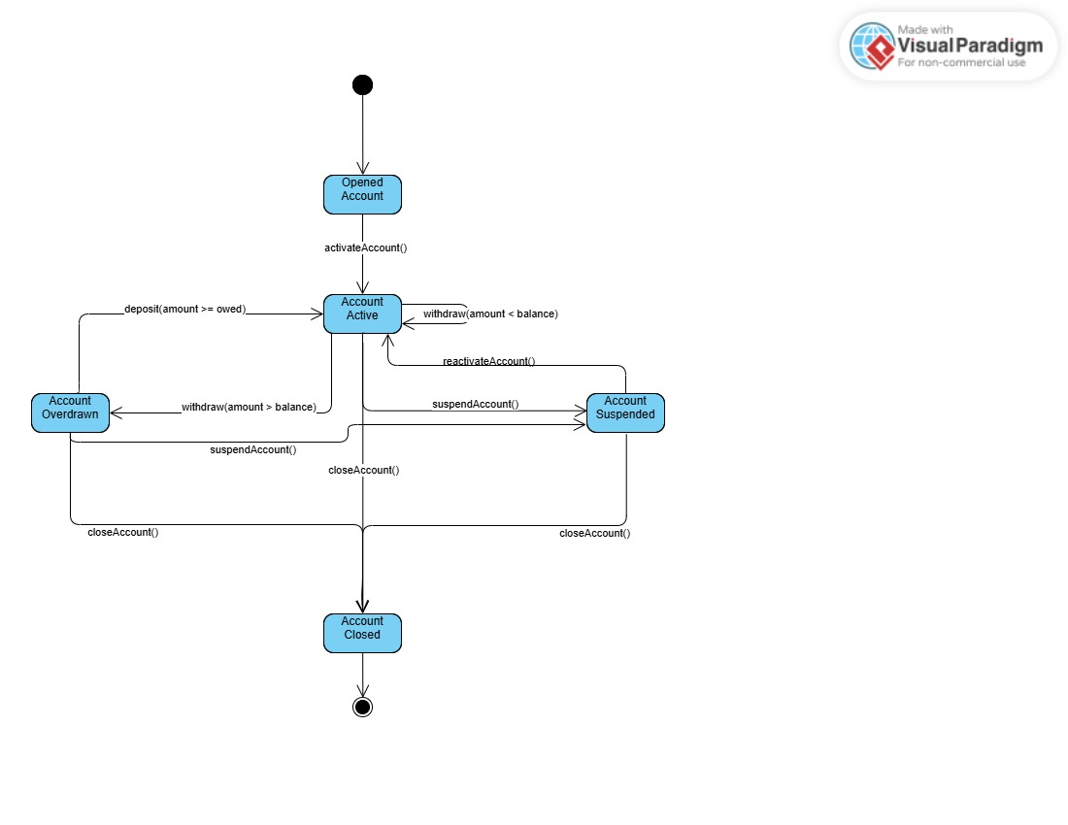

Meeting record appendix:

Date: September 18, 2025

Time: 10:30AM-12:30AM

Place: Online

Name of Interviewee: Mr. Kentsenao Baseki

Role of Interviewee: Banking Client

Name of Interviewer: Mr. Felix Kabira Kagwi

Questions and Answers:

1. What is the main purpose of the banking system?
   1. The system should allow a customer to open accounts, deposit and withdraw money, and also view their transaction history.
2. Who is the intended user of this banking system?
   1. Individuals and Companies/Organizations
3. What information is required to open an account?
   1. For a company to open an account we would need the necessary company details. For an individual to open a savings account we would need their personal details, while for an investment account we would need a minimum of P500 to open the account, and for a cheque account we would need their employee details.
4. Can a customer have more than one account?
   1. Yes, a customer can open multiple accounts being: cheque, investment or savings account.
5. What rates should be applied on the savings account?
   1. For an individual’s saving account, it should be 0.025 per month, while for a Company/Organization it should be 0.075 per month but a cheque account does not earn interest.
6. How should a user login into the system?
   1. By providing their Username and password.
7. Where should customer details be stored?
   1. In a secure database.
8. What operations should customers be able to perform on their accounts? Check balance, deposit, and withdraw.